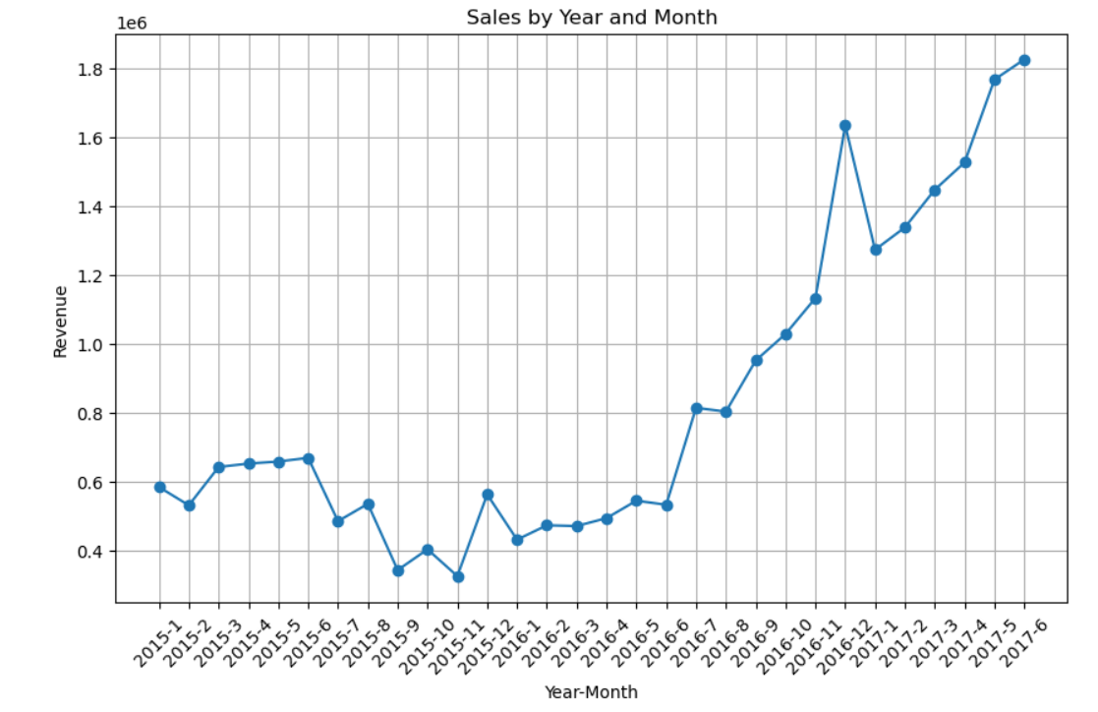

**Sales Performance Report**

**Introduction**

This report analyzes the sales performance of the company from January 2015 to June 2017. The focus is on identifying trends in revenue over time, particularly through a time series analysis that reveals the sales growth trajectory across different months and years.

**Data Visualization**

**Error! Filename not specified.**

**Description of the Chart**

The chart represents monthly sales revenue from January 2015 to June 2017. The x-axis shows the year and month, while the y-axis indicates the total revenue generated during those months.

**Insights**

1. **Overall Growth Trend**:
   * From the graph, there is a noticeable upward trend in sales revenue, especially after the mid-point of 2016. This suggests an improvement in sales performance over time.
2. **Seasonal Patterns**:
   * The data reveals fluctuations in revenue, indicating possible seasonal effects on sales. Periods of lower revenue, particularly in 2015, were observed, followed by gradual increases.
3. **Sharp Increase Post-2016**:
   * There was a significant spike in revenue starting from mid-2016. This could correlate with strategic business changes, such as marketing campaigns, new product launches, or seasonal demand fluctuations.
4. **Volatility in 2015**:
   * The early months of 2015 show more volatility in sales, with several dips and rises. This might suggest instability in customer acquisition or changes in market conditions.
5. **Recent Performance**:
   * By mid-2017, the revenue appears to stabilize at a higher level, suggesting that the company has established a strong market presence.

**Recommendations**

1. **Investigate Growth Drivers**:
   * Conduct further analysis to identify what specific strategies contributed to the increased sales post-2016. This could involve looking into marketing efforts, product development, and customer feedback.
2. **Maintain Momentum**:
   * Continue investing in successful marketing strategies and product offerings that have shown to increase revenue. Consider scaling successful campaigns.
3. **Address Seasonal Variability**:
   * Implement promotional activities during historically low-revenue periods to smooth out fluctuations and stabilize monthly revenue.
4. **Monitor Market Trends**:
   * Stay abreast of market conditions and competitor actions to adjust strategies promptly. Regularly review sales data to identify patterns that can inform product development and marketing strategies.
5. **Customer Engagement**:
   * Enhance customer engagement strategies to boost loyalty and repeat purchases, especially during periods of lower sales.
6. **Expand Data Analysis**:
   * Utilize more advanced analytics techniques, such as predictive analytics, to forecast future sales trends and inform strategic decision-making.

**Conclusion**

The sales analysis from January 2015 to June 2017 indicates a positive growth trajectory for the company, particularly post-2016. By leveraging insights gained from this report, the company can build on its successes and address potential challenges, ultimately aiming to enhance overall performance and market positioning.

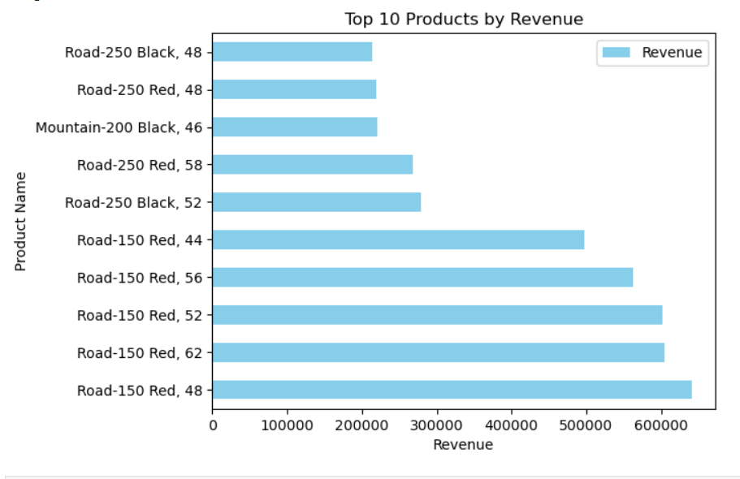

**Analysis of Top Products by Revenue**

**Visualization**

**Error! Filename not specified.**

**Description of the Chart**

This bar chart displays the top 10 products by revenue, highlighting their total sales contributions. The x-axis represents the total revenue, while the y-axis lists the product names.

**Insights**

1. **Top Revenue Generators**:
   * The top products include several variations of the "Road" and "Mountain" bikes, particularly the **Road-250** and **Road-150** series. These products have generated significant revenue, indicating their popularity and strong market demand.
2. **Product Variety**:
   * The presence of multiple variants (e.g., black and red color options) suggests that consumer preferences may vary by model and color. This indicates a diverse market where customers may have specific preferences that influence purchasing decisions.
3. **Revenue Distribution**:
   * The revenue distribution shows that certain products, especially the **Road-250 Red, 58** and **Road-150 Red, 62**, are leading in sales. These products may be leveraging effective marketing strategies or fulfilling a specific customer need.
4. **Potential for Growth**:
   * Products with lower revenue figures, such as the **Mountain-200 Black, 46**, indicate potential opportunities for targeted marketing efforts to boost sales. Understanding customer demographics and preferences can help drive sales for these underperforming products.

**Recommendations**

1. **Market Analysis for Top Products**:
   * Conduct a detailed analysis of the customer segments purchasing the top-performing products to understand their preferences and behaviors. Tailoring marketing strategies to these demographics can further enhance sales.
2. **Promote High-Potential Products**:
   * Develop targeted promotional campaigns for products with lower revenue but high potential. Consider bundling these products with top sellers to increase visibility and drive sales.
3. **Inventory Management**:
   * Ensure that high-demand products are well-stocked to meet consumer needs. Analyze sales patterns to forecast inventory requirements accurately.
4. **Feedback Mechanism**:
   * Implement a system for gathering customer feedback on product variations, particularly color and features, to inform product development and marketing strategies.
5. **Seasonal Promotions**:
   * Utilize insights from seasonal sales trends to schedule promotions for specific product lines during peak buying periods, ensuring optimal visibility and customer engagement.
6. **Expand Product Line**:
   * Consider developing new products based on successful attributes identified in top-performing items. This could involve exploring variations in design, features, or pricing strategies to capture broader market segments.

**Conclusion**

The analysis of the top products by revenue indicates a strong performance for certain models while revealing opportunities for growth in others. By leveraging these insights and recommendations, the company can enhance its product strategy, align marketing efforts with customer preferences, and ultimately drive increased sales and market share.